EXP 04:

AIM: Write a C program to check whether a given string belongs to the language defined by a Context Free Grammar (CFG)

S → 0S0 | 1S1 | 0 | 1 | ε

INPUT:

#include<stdio.h>

#include<ctype.h>

#include<string.h>

int main(){

char str[15];

int l,i,flg=0;

printf("\n\tTHE GRAMMER PRODUCTIONS\n\tS --> 0S0 | 1S1 | 0 | 1 | EPS");

printf("\n\nEnter the string:");

scanf("%s",str);

l=strlen(str);

if(((str[0]=='0')&&(str[l-1]=='0'))||((str[0]=='1')&&(str[l-1]=='1'))){

for(i=0;i<l;i++){

if(isalpha(str[i])){

flg=1;

break;

}

else if((str[i]!='0')&&(str[i]!='1')){

flg=1;

break;

}

}

if(flg==1)

printf("\nINVALID INPUT");

else if(flg==0)

printf("\nVALID INPUT");

}

else

printf("\nINVALID INPUT");

}

OUTPUT:

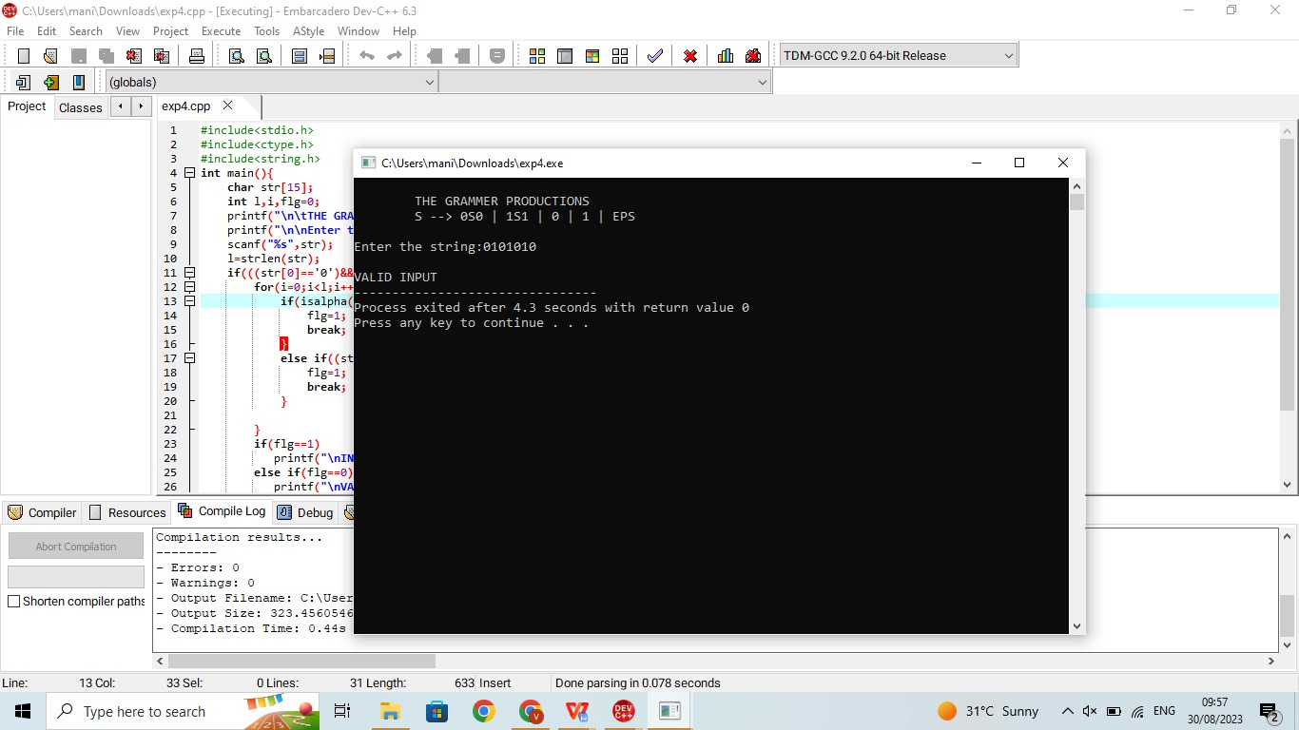

RESULT:The programm is successfully executed in dev c++